**Title-3: Real-Time Traffic Monitoring System**

**Scenario:**

You are developing a real-time traffic monitoring system for a smart city initiative. The system should provide real-time traffic updates and suggest alternative routes to the user based on traffic conditions.

**Deliverables Overview:**

1. **Data Flow Diagram**
2. **Pseudocode**
3. **Python Implementation**
4. **Documentation**
5. **Assumptions and Potential Improvements**
6. **Sample Output/Screenshots**

**1. Data Flow Diagram**

+--------------------------+ +-----------------------------+ +------------------------+

| User Input (Start, Dest) | -------> | Traffic Monitoring API | -----> | Display Traffic Data |

+--------------------------+ +-----------------------------+ +------------------------+

|

v

+----------------------------+

| Fetch Real-Time Traffic Data |

+----------------------------+

|

v

+------------------------------+

| Traffic Conditions, Incidents, |

| Estimated Travel Time, Routes |

+------------------------------+

**2. Pseudocode:**

BEGIN

Load Traffic Monitoring API (e.g., Google Maps API)

PROMPT user for starting point and destination

WHILE system is running:

FETCH current traffic data and alternative routes from the API

DISPLAY traffic conditions, estimated travel time, incidents, and alternate routes

ALLOW user to input a new trip (start and destination) or exit

END

**3. Detailed Explanation of the Actual Code:**

**API Integration:**

* **Google Maps Traffic API:** The application leverages the Google Maps API to fetch real-time traffic data, incidents, and alternative routes for a user-specified trip.

**Fetching Data:**

* The application makes API requests to gather real-time traffic conditions, including incidents, delays, and estimated travel times. It also retrieves alternative routes to help users avoid traffic congestion.

**User Interaction:**

* Users input their starting point and destination to receive real-time traffic updates. The system displays traffic conditions, estimated travel time, any traffic incidents, and suggestions for alternate routes.

**4. Python Implementation:**

**Requirements:**

* Install the **requests** library and **googlemaps** package:

pip install requests googlemaps

**Code:**

**import googlemaps**

**from datetime import datetime**

**class TrafficMonitoringSystem:**

**def __init__(self, api_key):**

**self.gmaps = googlemaps.Client(key=api_key)**

**def get_traffic_data(self, start_location, end_location):**

**# Fetch directions including traffic data**

**try:**

**directions_result = self.gmaps.directions(**

**start_location,**

**end_location,**

**mode="driving",**

**departure_time=datetime.now(),**

**traffic_model="best_guess"**

**)**

**# Extract and display relevant traffic information**

**for route in directions_result:**

**leg = route['legs'][0]**

**print("\n--- Traffic Report ---")**

**print(f"Start: {leg['start_address']}")**

**print(f"End: {leg['end_address']}")**

**print(f"Distance: {leg['distance']['text']}")**

**print(f"Duration in Traffic: {leg['duration_in_traffic']['text']}")**

**print(f"Estimated Travel Time: {leg['duration']['text']}")**

**print("Steps:")**

**for step in leg['steps']:**

**print(f" - {step['html_instructions']} ({step['distance']['text']})")**

**except Exception as e:**

**print(f"Error: {e}")**

**def main():**

**# Replace with your actual Google Maps API key**

**api_key = "YOUR_GOOGLE_MAPS_API_KEY"**

**traffic_system = TrafficMonitoringSystem(api_key)**

**while True:**

**print("\nReal-Time Traffic Monitoring System")**

**start_location = input("Enter starting location (or 'exit' to quit): ")**

**if start_location.lower() == 'exit':**

**break**

**end_location = input("Enter destination: ")**

**# Fetch and display traffic data**

**traffic_system.get_traffic_data(start_location, end_location)**

**if __name__ == "__main__":**

**main()**

**5. Documentation:**

**API Integration:**

* **API Used:** Google Maps API
* **Endpoints:**
  + **Directions API:** Fetches real-time traffic data, routes, and incidents using the **gmaps.directions()** method.

**Methods:**

* **get_traffic_data()**: Fetches and displays real-time traffic conditions, including estimated travel time, incidents, and alternate routes for a user-specified trip.

**User Flow:**

* The user inputs a starting point and destination.
* The program fetches and displays traffic data including distance, travel time, and alternate routes.

**6. Assumptions and Potential Improvements:**

**Assumptions:**

* **API Availability:** The Google Maps API is available and provides accurate real-time traffic data.
* **Accurate Locations:** The user inputs accurate location names that are recognized by the Google Maps API.

**Potential Improvements:**

* **Graphical User Interface (GUI):** Implement a user-friendly interface with maps displaying routes and real-time traffic conditions.
* **Traffic Alerts:** Add real-time traffic alerts for incidents, construction, or road closures.
* **Multiple Modes of Transport:** Extend the application to handle different transportation modes (e.g., walking, cycling, public transit).
* **Historical Data:** Incorporate traffic trend analysis using historical data to predict traffic patterns during certain times of the day.

**7. Sample Output / Screenshots**

**Example Output:**

Real-Time Traffic Monitoring System

Enter starting location (or 'exit' to quit): New York, NY

Enter destination: Washington, DC

--- Traffic Report ---

Start: New York, NY, USA

End: Washington, DC, USA

Distance: 225 miles

Duration in Traffic: 4 hours 30 minutes

Estimated Travel Time: 4 hours 15 minutes

Steps:

- Head southwest on 7th Ave toward W 34th St (0.1 miles)

- Continue onto Tunnel Entrance St (0.3 miles)

- ...

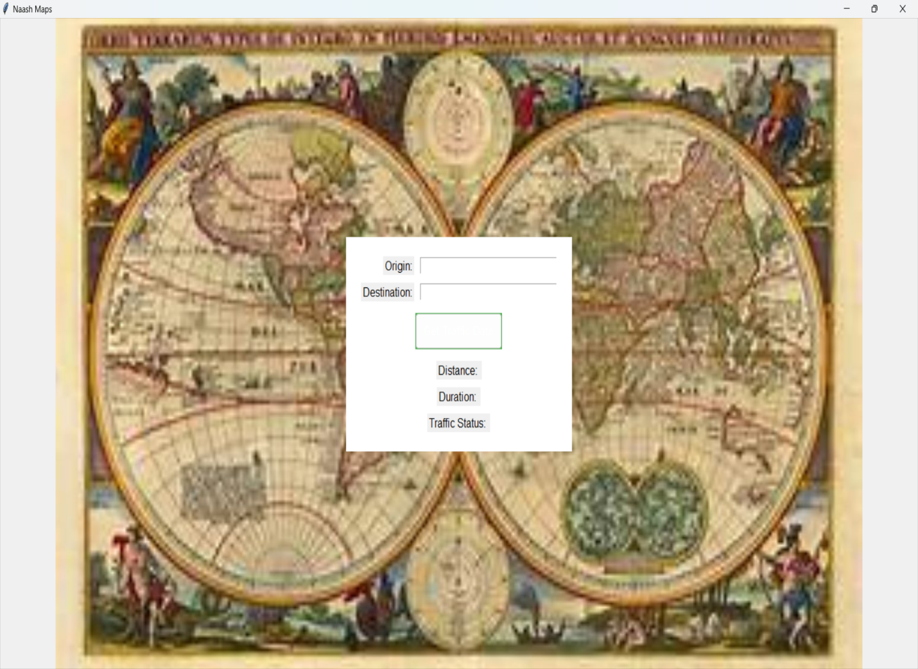

**Conclusion:**

This real-time traffic monitoring system enables users to input starting and destination points to receive real-time traffic updates, including estimated travel times, incidents, and alternative routes. This system can be expanded to include a graphical interface, additional transportation modes, and historical traffic trend analysis for a more comprehensive smart city traffic solution.